How the YouTube recommendation system works?

Philip Belov

November 7, 2015

The goal of this recommendation system is to satisfy the user’s needs by bringing videos that it believes the user will be interested in. It also has another goal that is not user-centered and it’s increasing the numbers of videos that users will watch as well as the time he spends using the service.

The main question is ‘how the YouTube video recommendation system actually works?’.

Firstly, we must define the data sources that can be used to actually generate the various recommendations for a particular user. The two main sources of data that the system draws from are content data and user activity data. The content data is, for example, metadata or description of a video. The user activity data includes explicit attributes, e.g. ratings and favourites, inclusion in playlists, and implicit attributes, such as view time. (“How Does the YouTube Recommendation System Work?” 2015)

Those are some of the factors. However, there are also some thresholds that must be considered by the system: for example, a date of a video upload (if a user watched a video a long-long time ago, it’s not likely you want to use it to make a recommendation based on that video). The YouTube video recommendation systems also uses, what is called, related videos association to provide recommendations to the user. (Anonymous 2013) The system utilizes a number of limiting factors too: e.g., amount of videos from a certain uploader/channel.

The set of recommendation candidates can be considered as a vector. To determine this set the system finds related videos that a user is likely to watch after viewing a given seed video. (Davidson et al. 2010) There are a couple of techniques that can be used to generate a set of related videos. The first one is association rule mining which is a method for discovering relations between variables in large datasets and another one is co-visitation counts. The co-visitation count is a value that is calculated in the following way: for each pair of videos we count how many times they we co-watched within one session. The second method is used to evaluate the, so called, relatedness score of a video to another video.  After computing a relatedness score for videos the system makes use of related association rules with a user’s activity on the service: a history of watched videos (limited by a certain threshold), a list of favorited, liked, rated videos. Therefore, the list of candidate videos is generated. (Davidson et al. 2010)

The next step is ranking the videos that have made their way into the candidates list. The ranking process is made considering videos’ quality, user specificity and diversification. The quality of video is determined by such signals as view count, ratings, comments, favorites and sharing activities. (Linden 2011)

User specificity means that a user will get videos that are most close to his preferences. It’s determined by such properties as view count and time of watching. The next factor – diversity – means that videos are too similar to one another are excluded from the candidates list, which further brings a wider diversity to the set. It’s driven by the logic that user has multiple interests  and corresponding viewing preferences. So, the list of recommendations includes not only videos that are similar to the video that is being seeded to a user.

Besides methods mentioned in the above passages, there are some other techniques that might be used during the recommendations generating process. For example, there’s an opinion that the recommendation system uses similarity metrics. So, there’s a vector that represents each user’s whole watched history. And by comparing these vectors, similar videos can be found for people that share some tastes. The tools that can be used to actually compare these vectors and perform calculations are Johnson-Lindenstrauss lemma, Jaccard Similarity, Cosine Similarity and Lj distances. Also, Pearson correlation can be utilized to find a similarity between two users. (Mizumoto 2014)

Some clustering algorithms, which is a form of unsupervized learning, might be used to determine a structure in a set of what-seems-to-be-random data. These algoritms work by identifying similarities among items (users) by calculating their distance from other items in a feature space. Features can be, for example, a number of videos watched by a user from a certain amount of videos. The dependency of the features must be calculated (for example, with Pearson correlation method) to define the dimensionality of the space. If items are considered as “close” to each other, then they’re joined in a cluster. (Kumar 2014)

In my opinion, despite other views, the videos that user watched and the whole YouTube videos database should not be considered as a vector. It might be more logical to implement the database as a graph where vertexes would be videos. Edges with corresponding weights would be representing the correlation – how strongly they are related to each other – between two videos.  For example, a user had watched and then liked video “A” then we provide him with a set of suggested videos that the system has generated. If the user liked the suggested video “B" then we increase the weight of the edge between videos “A” and “B”.

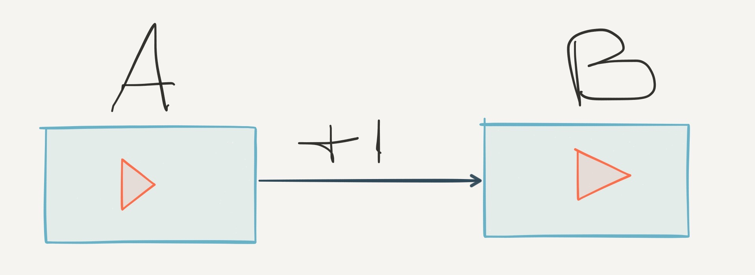

However, in my view, this system can be applied not only to YouTube service but for the other types of online services like for example Amazon (for related products, suggestions for purchases) and online shops in general. It can also be used in Instagram “follow” suggestions (after the user clicks the “Follow” button there’s a list of 3 accounts to follow).

In conclusion, I’d like to say there’s a long way for the development of recommendation systems. They can be improved significantly, in my opinion, because some suggestions that typical reccommender systems provide for the user are far from perfect.

Anonymous. 2013. “What Recommendation System Algorithm Is Used by Big Social Giants Like Facebook and YouTube?” <https://www.quora.com/What-recommendation-system-algorithm-is-used-by-big-social-giants-like-Facebook-and-YouTube/answers/2249453>.

Davidson, James, Benjamin Liebald, Junning Liu, Palash Nandy, Taylor Van Vleet, Ullas Gargi, Sujoy Gupta, et al. 2010. “The YouTube Video Recommendation System.” In *Proceedings of the Fourth ACM Conference on Recommender Systems*, 293–96. ACM.

“How Does the YouTube Recommendation System Work?” 2015. <http://trouvus.com/blog/how-does-the-youtube-recommendation-system-work/>.

Kumar, Aditya. 2014. “What Recommendation System Algorithm Is Used by Big Social Giants Like Facebook and YouTube?” <https://www.quora.com/What-recommendation-system-algorithm-is-used-by-big-social-giants-like-Facebook-and-YouTube/answer/Aditya-Kumar-315>.

Linden, Greg. 2011. “YouTube Uses Amazon’s Recommendation Algorithm.” <http://glinden.blogspot.in/2011/02/youtube-uses-amazons-recommendation.html>.

Mizumoto, Weston. 2014. “How Does YouTube’s Recommendation Algorithm Work?” <https://www.quora.com/How-does-YouTubes-recommendation-algorithm-work/answer/Weston-Mizumoto>.